User on checkout form and filled the details with invalid name and city

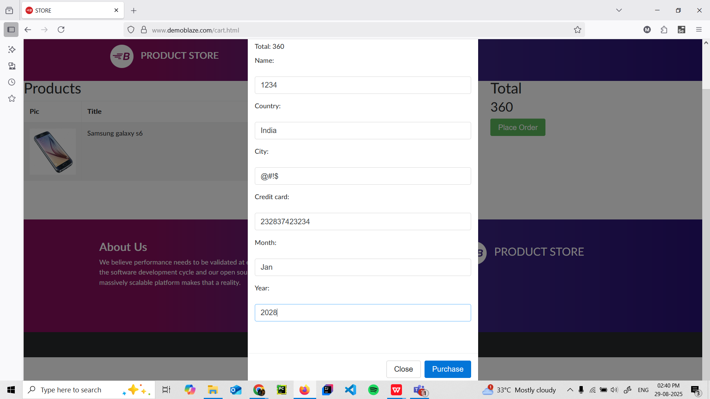

Purchase successful card is shown with id, amount, card number, name, date

